# **RUDIMENTS OF MUSIC**

# 

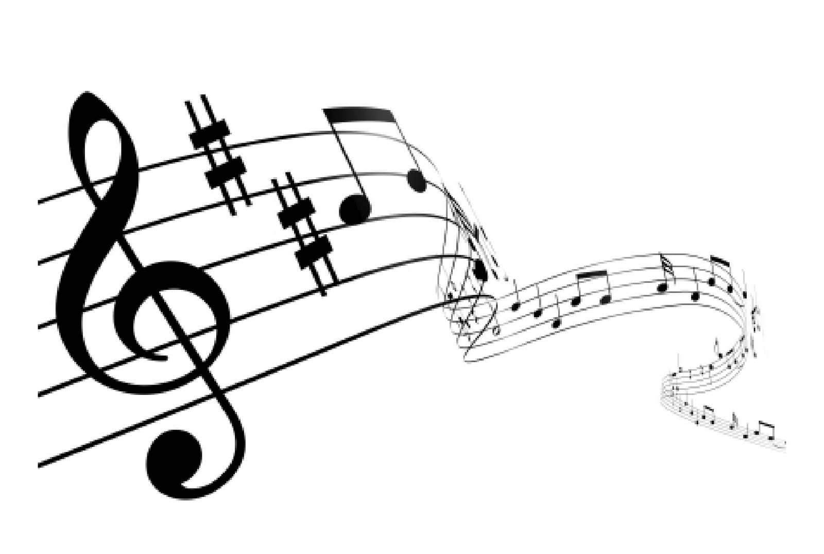

**“O come, let us sing unto the LORD: let us make a joyful noise to the rock of our salvation. Let us come before his presence with thanksgiving, and make a joyful noise unto him with psalms.” – Psalm 95:1-2**

# **DEEPER CHRISTIAN LIFE MINISTRY, NORTHERN EUROPE**

Table of Contents

**1. Introduction to music 3**

**1.1 What is music ? 3**

**1.2 Characteristics of music/sound 3**

**2. The Stave 3**

**2.1 Treble stave 3**

**2.2 Bass Stave** **4**

**2.3 The Ledger Line 4**

**2.4 The Clef 4**

**2.5 Barlines 5**

**3. Musical Notes and Rests 6**

**3.1 Description of musical notes and rests** **7**

**3.2 Clapping and Rhythm 8**

**3.3 Dotted Notes** **9**

**3.4 Ties 9**

**4. Key Signature 10**

**4.1 Meaning and function of the key signature 10**

**4.2 Sharp Sign #** **11**

**4.3 Flat Sign♭ 11**

**4.4 Accidentals** **12**

**4.4.1 The Octave** **12**

**4.4.2 Sharps and flats** **12**

**4.4.3 Barlines and accidentals** **13**

**5. Time Signature** **14**

**6. Musical Signs 15**

**6.1 Main Musical Signs 15**

**6.2 Other Musical Terms 16**

**7. Sight Reading - A Primer…………………………………………………………………………….....17**

## Introduction to music

## What is music?

Music is a combination of sounds that are agreeable to hearing.

## Characteristics of music/sound

Music/Sound is characterized by the following:

* **Pitch**: this is the height or depth of a sound. The higher a note is on a staff, the higher its sound.
* **Intensity or quantity**: this is the degree of loudness of a sound. For example, pp(very soft), mp(moderately soft), p(soft), ff(very loud), f(loud),mf(moderately loud), crescendo(becoming gradually louder), diminuendo (becoming gradually softer).
* **Timbre or quality**: this is the characteristic property that distinguishes a particular musical sound from another, even when they have the same pitch and quantity e.g. the difference between the sound of an organ and that of a flute, the human voice and that of a trombone.
* **Accent:** this is the emphasis or stress on a note.
* **Duration**: this is how long a note lasts.
* **Tonal relationship:** this is the arrangementof sound into scales and keys**.**
* **Rhythm:** this is the movement of music, quick or slow, lively or soothing.

**Melody:** this is the actual line of the song; the way the song is sang or played without parts or harmony.

## The Stave

Music is written by placing the notes on a staff/stave. The music staff consists of five lines and four spaces. These lines and spaces are named using the first seven alphabets: A-B-C-D-E-F-G.



## Treble stave



The spaces are D-FACE-G.

The lines are E-G-B-D-F. You can try to remember the letter names of the notes on lines by learning:

Every - Good - Boy - Deserves – Favour.

## Bass Stave



Good - Boys - Deserve – Favour – Always All – Cows – Eat – Grass (F-ACEG-B)

## The Ledger Line

Ledger lines are short lines that extend musical notes above or below the stave.

The two staves: the upper or treble stave and the lower or bass stave are joined together by a ledger line called **middle C** to form the **GREAT STAVE.**

The great stave consists of eleven lines and ten spaces.

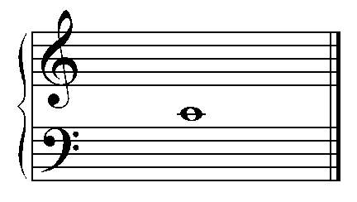

## The Clef

At the beginning of a stave is a sign known as **CLEF.** This sign fixes the pitch of the lines and spaces of the stave.

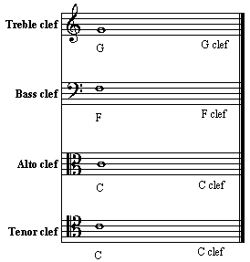

The most commonly used clefs are the treble and bass clefs.

Treble clef is also called G clef, because it originates from the line G.

G

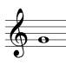

Bass clef is also known as F clef, because it begins at line F. Its two dots are placed on either side of the F line.



## Barlines

A stave is divided into bars by a bar line. A Bar line is an upright line drawn across the stave to divide it into equal proportions. A bar is a measure of time in which the music is divided into regular or equal beats. However, it is possible to have an irregular beat .The time signature determines the beats in a bar.

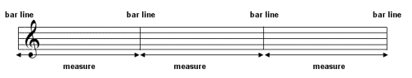

A double bar line (without dots) is a vertical line drawn across the stave to show the end of a line or the end of a piece. A double bar line with two dots on the left indicates that the player/singer should go back to the previous bar line with two dots on the right or to the beginning of the piece.

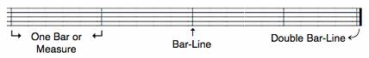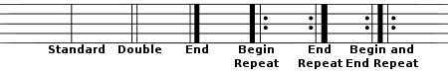

## Musical Notes and Rests

Musical notes are of different shapes and values. Most notes consist of a head (shaded or unshaded), stem and a flag, with the exception of the breve and semibreve (it has no stem and flag), minim and crotchet (they have no flags).

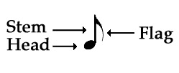

In music theory, ***Rests*** are symbols which tell you to stop playing/singing, and how long to stop. *Rests* come in different shapes depending on how long they last for, just like notes do. *Rests* take the same names as the notes of the same length.

## Description of musical notes and rests

Below are different kinds of musical notes, their names, values and rests.

|  |  |  |  |  |
| --- | --- | --- | --- | --- |
| **Musical notes/signs** | **Names** | **Values** | **Beats** | **Rests** |
|  | **Breve** | Double whole note |  |  |
|  | **Semibreve** | Whole note | 4 beats |  |
|  | **Minim** | Half note | 2 beats |  |
|  | **Crotchet** | Quarter note | 1 beat | or |
|  | **Quaver** | Eighth note | ½ beat |  |
|  | **Semiquaver** | Sixteenth note | ¼ beat |  |
|  | **Demisemiquaver** | Thirty-second note | 1/8 beat |  |
|  | **Hemidemisemiquaver** | Sixty-fourth note | 1/16 beat |  |
|  | **Semihemidemisemiquaver** | Hundred-twenty-eighth note | 1/32 beat |  |

The first musical note and the last three ones are rarely seen in today’s music.

The semibreve note is made up of two minim notes, four crotchet notes and eight quaver notes.

A minim consists of two crotchet notes, four quaver notes and eight semiquaver notes.

The breaking down is further summarized in the diagrams below:

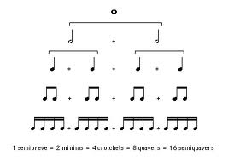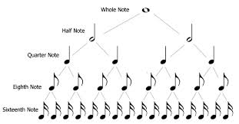

## Clapping and Rhythm

A semibreve note has 4 beats and should be clapped once but held till after the count of four.

A minim has 2 beats: clapped once and be held for the duration of two beats.

A crotchet has 1 beat and should be clapped once.

A quaver however, has an half beat. It should be clapped though once but faster.

**Exercise:** Try and clap the following notes.

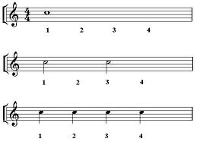

## Dotted Notes

In music theory, all *notes* and *rests* can have their lengths increased if we add one or more ***dots***. *Notes* with *dots* are called ***dotted notes***. *Dots* are always placed on the right side of the note head. *A dot* makes *a note* or *rest* longer by 50%. Or, in other words, *a dotted note* is equal to *itself* plus *half of itself*.

|  |  |
| --- | --- |
|  | Crotchet/Quarter note=  1 beat |
|  | Dotted crotchet/quarter note=  1 + ½ beat = 1 and a half beats |
|  | Minim/Half note=  2 beats |
|  | Dotted minim/half note=  2 + 1 = 3 beats |
|  | Quaver/Eighth note=  ½ beat |
|  | Dotted quaver/eighth note= ½ + ¼ = three quarters of a beat |

## Ties

A tie is a curve line that joins two or more notes of the same pitch. This means that a tie can only join musical notes that are on the same line or in the same space. The notes joined can be in the same bar or in bars that follow each other.

Here are some examples showing how notes are joined together by ties.  
  
**(**A semibreve joined with a crotchet)

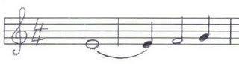

**(Two dotted minims joined together)**

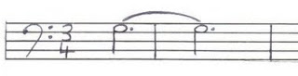

A tie can be thought of as a plus sign (+). It adds the length/duration of two notes together.

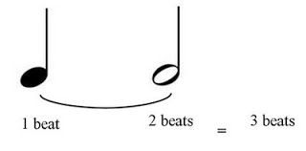

The illustration above shows a crotchet and a minim joined together by a tie. When both notes are tied together they create one sound lasting as long as 3 beats.

## Key Signature

## Meaning and function of the key signature

A key signature is a set of **sharp** *♯* or **flat**♭symbols placed together on the stave. These symbols are generally placed immediately after the clef at the beginning of a stave. It is also possible to see any of these signs elsewhere in a piece of music. When this happens, they are referred to as accidentals. More will be discussed about this later.

To make it easier to understand at this level of music, the key signature is what guides in knowing where the “do” sound is in a music piece. Once this is known, the rest of the music will be easy to transcribe. It is important to state that, this does not mean that one’s first note will always be “do”, it depends on the music composer.

Let us take a quick look at the **Tonic Solfa** before we proceed. Simply put, the tonic solfa is:

do re mi fa so la ti do : ascending order

do ti la so fa mi re do: descending order

## Sharp Sign #

A sharp sign raises the pitch of a note by a semitone.

The number of sharp sign(s) in a music, determines what key it is called.

Again, at this level, we will only focus on the major key signatures.

Below is a table to explain this.

|  |  |  |
| --- | --- | --- |
| **Number of Sharps** | **Key** | **Notes to be sharpened (for instrument players).** |
| **0** | C | - |
| **1** | G | F |
| **2** | D | F C |
| **3** | A | F C G |
| **4** | E | F C G D |
| **5** | B | F C G D A |
| **6** | F sharp | F C G D A E |

A music piece with no sharp sign after the clef is a music on Key C. This then means that “do” is on C ( be it on middle C or the third space on treble stave/ for bass stave, third space from below). Please, refer to the naming of both the Treble and Bass clefs.

Having known where “do” is, one can then transcribe the rest of the music.

For example, the first note for a treble singer is on line E, this note will be “mi”.

**Exercise: GHS 136 - At Calvary.**

For a music with one sharp sign, the key is G meaning that the “do” is on the second line on treble stave and the first line on bass stave.

To be able to remember these keys, this acronym can be used: **G**o **D**own **A**nd **E**nter **B**y **F**aith.

## Flat Sign♭

A flat sign lowers the pitch of a note by a semitone. The key of a music depends on the number of flats.

|  |  |  |
| --- | --- | --- |
| **Number of flat** | **Key** | **Notes to be flattened (for instrument players).** |
| **0** | C | - |
| **1** | F | B |
| **2** | B flat | B E |
| **3** | E flat | B E A |
| **4** | A flat | B E A D |
| **5** | D flat | B E A D G |
| **6** | G flat | B E A D G C |

A music with one flat is on key F, so that will be on the first space of the treble stave and on the fourth line of the bass stave from below. Should the first note of treble be on line B, it means that the first note is “fa”.

**Exercise: GHS 43 - Trust and Obey**

To be able to remember these keys, this acronym can be used: **F**or **B**etter **E**nd **A**lways **D**o **G**ood.

For more exercises on key signatures, the music instructors should please spend more time to practice with the brethren using simple music.

## Accidentals

In music theory, the term ***"Accidentals"*** is used to describe some notes which have been slightly altered. ***Accidentals*** are the symbols which are placed before the note on the *Stave* - they can be "*Sharps*", "*Flats*" or "*Naturals*". In this unit we'll have a look at what *Accidentals* are exactly and how they are used in music theory.



## The Octave

To begin, let’s look at a piano keyboard again. The yellow note is middle **C**, and the green note is the next **C** above it. How many different notes are there between these two **C**s?

If we count all the black and white notes, we’ll find there are 12 different notes. *(Don’t count the C twice!)* This span of notes is called an "***Octave***" in music theory. This isn’t only true for the piano – every instrument uses the same series of notes.

## Sharps and flats

So, we have 12 different notes, but we only use 7 letters of the alphabet. We use the words “***Sharp***” *(=higher)* and “***Flat***” *(=lower)* with a letter name, to cover all those “*in-between*” notes. ***Sharps*** and ***Flats*** are two kinds of "***Accidentals***".

We can use symbols for accidentals, instead of the words *Sharp* and *Flat*.

*♯* Sharp symbol

♭ Flat symbol

Sharps: de re fe se le

Do re mi fa so la ti do

Flats: raw mo saw lo to

Find the notes **C** and **D** on this keyboard:



They are both white notes *(but we've coloured the C in yellow to help you find it!)*. In between them, you’ll see a black note. We can say that this note is a bit higher than **C**, so it is “*C sharp*” (**C♯**), or we can say it is a bit lower than **D**, so it is also “*D flat*” (**D**♭).

Here’s another example.



Find the notes **F** and **G**. The black note in between **F** and **G** can be called *F Sharp* (**F♯**) or *G Flat* (**G**♭).

Naturals

The third type of accidental we are going to look at is called the "***Natural***". We use the word “***Natural***” (or the symbol ♮) to say that a note is neither *Sharp* nor *Flat*. This is very useful, because sometimes when a note has already been altered by an *Accidental* (*Flat* or *Sharp*), we need to put a natural sign in to tell the player that it isn't flat or sharp any more. *Flats*, *Sharps* and *Naturals* make up the main *Accidentals*, and they are the only accidentals you need to know for grade one music theory.

## Barlines and accidentals

When an *Accidental* has been written, all the other notes which are the same pitch, *(or position on the Staff)*, are also affected by the *Accidental*, but only until a *Barline* is drawn.

Here’s an example:



1 is *Natural*, because we haven’t put any *Accidentals*.

2 is *flattened* by the *Flat* symbol.

3 is also *flattened* by the symbol from number 2.

4 is *Natural*, because the *Barline* cancels the effect of the *Flat*.

5 is *flattened* by the *Accidental* symbol.

6 is *naturalised* by the *Barline*.

Notes of the same letter name, but which occupy different positions on the staff, are not affected by each other’s *Accidentals*.



3 is an A *Natural*. The *Flat* on number 2 doesn’t affect it, because it’s not the same pitch – it’s an *Octave* higher.

## Time Signature

Time signature indicates the number of beats in a bar/measure. It consists of two figures: the upper figure (numerator) represents the quantity, that is, the number (how many) of beats. The lower figure (denominator) is the quality, this represents the value of each beat.

Time signature also guides in musical conduction.

Examples are: 2 3 2 3 6 6 9

2 4 4 4 8 8 8

2 The lower figure (2) shows that the value is about minim.

2 This means there are 2 minim beats in a bar.

A minim is a beat. A crotchet is half beat.

A quaver is one-quarter beat. A semibreve is two beats.

3 In this time signature, the lower figure 4 indicates crotchet as the value.

4 Meaning that there are three crotchet beats in a bar.

A crotchet is one beat. A quaver is half beat.

A minim is two beats. A semibreve is four beats.

6 Here, the lower figure 8 points quaver as the value.

8 The time signature means that there are six quaver beats in a bar.

A quaver is a beat. A semiquaver is half beat.

A crotchet is two beats. A minim is four beats.

A semibreve is eight beats.

**NB: TIME SIGNATURE IS NOT A FRACTION, THEREFORE, NO LINE IN BETWEEN THE FIGURES.**

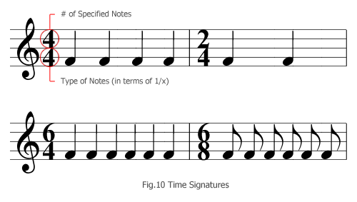

## Musical Symbols

## 6.1 Main Musical Symbols

Symbols in music have many different shapes and uses. They are useful because they give us information quickly, without us having to read words.

Symbols which are attached to notes are written on the opposite side to the stem.

|  |  |  |
| --- | --- | --- |
| **Musical symbol** | **Names** | **Significance** |
|  | **Tie** | The two (or more) notes should be played as one note. |
|  | **Slur (or "legato")** | The two (or more) notes should be played as one phrase |
|  | **Crescendo** | Gradually getting louder |
|  | **Decrescendo or Diminuendo** | Gradually getting softer. |
|  | **Accent** | Attack the note with a hard force |
|  | **Pause** | Hold on to the note for some time longer than real value of the note |
|  | **Repeat** | Single repeat bar. Go back to the beginning and repeat everything up to this bar. |
|  | **Double Repeat** | Double repeat bars. Repeat everything between the two repeat bars |

## 6.1 Other Musical Terms

**Adagio**: slow

**Andante:** rather slow (walking pace)

**A tempo:** resume the normal tempo (after a specified deviation) **Allegro:** quick **Brilliante:** in a brilliant showy style

**Con spirit:** with quickness and spirit **Da Capo or D.C:** go back to the beginning **Dal Segno D.S :** go back to the sign

**Fine:** the end

**Forte:** loud **Legato:** In a smooth connected manner **Piano:** soft **Poco a Poco:** little by little

**Unison:** Two or more parts sounding the same note.

## Sight Reading – A Primer

We will now look at how some of the theory of music concepts considered earlier e.g. time signature, key signature, rests, dotted notes etc, can be applied to sight reading a music by using tonic solfas (Recall that we learnt about Tonic Solfas in Lesson 4 above).

Simply put, sight reading, or sight singing, is the ability to reproduce written music vocally or through a musical instrument.

Let us take a quick look at extracts of a common nursery rhyme, “**Old MacDonald”**:

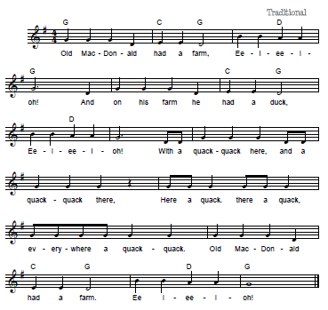

The Key Signature of the music above is G major. This is because the music has 1 sharp (on Line F).

The second line on the stave, Line G is the “do” note. Remember that this is a Treble stave.

The Time Signature of the music is 4

4

This means that there are 4 crotchets beats in a bar - A crotchet is one beat. A quaver is half beat. A minim is two beats and a semibreve is four beats.

Now, let’s sight read some of the notes –

- Notes 1, 2 and 3 of the music are on the second line of the stave (Line G) and are all “dos”.

- Note 4 is the space below the first line of the stave (Space D) and is a lower “so”

- Notes 8 & 9 are on the third line of the stave (Line B – one line and one space above Line G) and are both “mis”.

- Notes 10 & 11 are on the second space of the stave (Space A – immediately after Line G) and are both “res” etc.

- Note 12 is a dotted minim. Remember that a minim will normally have two beats in this music. A “dotted” minim will have three beats (the dot makes the note longer by 50%).

- We have a “crotchet” rest on the 4th line of the music. This rest will be one beat.

**Exercise**: Now attempt to sight read/sing the music below, noting the key signature, time signature, notes’ beats, rests, dotted notes, ties and any other music theory concepts you have been taught so far.

**JOY TO THE WORLD**

